Ball State Paulding Co.
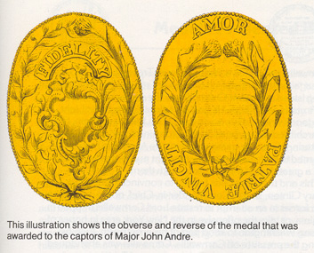

Paulding County: Ohio
The county was created in 1820 and later organized in 1839.^{[3]} It is named for John Paulding, one of the captors of Major John André in the American Revolutionary War. Major Andre was carrying in his boot, the plans for West Point received from Benedict Arnold. Nearby counties in Ohio were named for David Williams and Isaac Van Wart. Major Andre was hung on October 2, 1780.

Summary of Structures
19 – Miles of Canal Prism
6 – Locks Lift 28.75 feet
1 – Stone Culvert
1 – Reservoir
St Line
Miles M&E Lock # Lift Ft
19 Defiance / Paulding Co Line
19.33 Culvert –6 Mile Creek 30 Ft Chord
18.43 Junction, OH W&E / Miami & Erie
“W&E Abandoned 1877 (IN) & 1891 OH”
17.33 Lock No. 8 - OH 637 & 111 5 1 Mile Lock
13.06 Lock No. 9 Tate/s Ld (Reid) 4’ 9”
7.81 Lock No. 10 Reservoir Lock 6
7.0 6 Mile Reservoir 2500 a 2.5x1.6=3.5sq miles
5.04 Lock No. 11 Bank’s Lock 5
4.0 Antwerp, OH
2.8 Lock No. 12 Payne’s Lock 5
1.32 Lock No. 13 Doering’s Lock 3
0 Indiana Line – 380 miles to Evansville

