Ball State Henry Co.

Henry County: Ohio
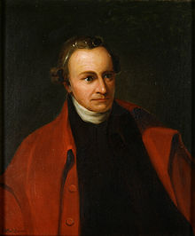
The county was created in 1820 and later organized in 1834.^{[3]} It is named for Patrick Henry, the Virginian famous for his "give me liberty or give me death" speech.

Summary of Structures
23 - Miles of Canal Prism
4 – Locks
6 – Stone Culverts
1 - Feeder Dam

St Line
Miles M&E Lock #
*Gilead Side-cut to Grand Rapids
57 Henry / Lucas Co Line
.5 Maumee Slackwater*
56.5 Lock No. 43 Bucklin’s Bulkhead
Lock No. 42 Rices’s / Ree’s
52 Bad Creek Culvert Texas
Lock No.41
Dry Creek Culvert
Turkeyfoot Creek Culvert
49 Damascus
Oberhaus Creek Culvert
44 Napoleon
Garrett Creek Culvert
Benien Creek Culvert
36 Florida
34 Henry / Defiance Co. Line

